# User documentation – ClusterProcessor

# About

Cluster Processor is a set of tools for processing the output of the Timepix3 detector. This detector was developed during the MediPix collaboration led by the CERN organization. Timepix3 is a hybrid pixel detector used in the Large Hadron Collider to capture the trajectories of the sets of elementary particles, also known as clusters. However, the amount of data generated in this process is too large for manual processing, which creates the need for automated tools which would help with processing and extracting information from the clusters. The extracted data can then be used for the classification of the clusters. The applications in the ClusterProcessor are the following:

* **ClassifierForClusters** is a console application that runs a given trained classifier on a selected dataset.
* **ClusterFilter** serves forselecting clusters based on their attributes for further processing.
* **ClusterViewer** provides a graphic user interface that visualizes clusters. It allows for interactive cluster visualization (one by one).
* **Description Generator** is a tool for generating the attribute file for the collection of clusters. This output file can be consequently used for training the classifiers.
* **ClassifierUI** provides a graphical interface with two main functionalities. Firstly, users can train a new classifier or re-train an existing classifier. And secondly, users can combine single-level classifiers into a multi-level cascade classifier.
* **ClassifierTrainer** is a console application with similar capabilities as ClassifierUI. It trains a classifier based on passed command line arguments.
* **ClusterExperiment** serves as a tool that performs classification experiments on a dataset of clusters. It trains multiple classifiers and evaluates their results.

In the following sections, we will show how to install the set of tools and use each of its individual applications.

# Installation

In order to run all of the primary applications in the ClusterProcessor solution, the user has two options.

1. Download the archived build (for Windows x64) of the solution accessible on the link: <https://github.com/TomSpeedy/ClusterProcessor>Executables. This method is suitable when you only plan to use the existing implementation.
2. Clone the solution from <https://github.com/TomSpeedy/ClusterProcessor>. This method is for those who would like to modify any of the tools of ClusterProcessor.

For compiling all of the tools, you will need the *.Net Framework* version 4.7. For further information about the *.Net Framework,* please visit <https://docs.microsoft.com/en-us/dotnet/framework/get-started/system-requirements>.

## Data formats

The tools work with clusters that are traces of one particle with possible traces of its decay detected by Timepix3, as shown in Figure 3.2. Raw data from the Timepix3 detector contains information on hits, energy, time of arrival, and time over the threshold for each pixel. These pieces of information are grouped together by the Clusterer application (accessible at <https://software.utef.cvut.cz/>). Hence the base format of the input is **MM cluster format.** This file format consists of 3 separate files – ini, cl, and px file.

|  |  |  |
| --- | --- | --- |
| **File** | **Format** | **Example** |
| ini | [Measurement (or any string ending with a newline char)] PxFile=[Relative path from the parent directory of .ini to px file]  ClFile=[Relative path from the parent directory of .ini to cl file] | Measurement 123 PxFile= Clusters_px.txt ClFile= Clusters_cl.txt |
| cl | [First ToA (decimal)] [Pixel Hit Count ( integer 0-232)] [LineOfStart in px file ( integer 0-232)] [Byte of start in px file (integer 0-232)] | 12345.647 100 5 30 |
| px | [x coordinate of the pixel ( integer 0-255)] [y coordinate of the pixel (integer 0-255)] [ToA (decimal)] [Energy (decimal)] | 123 128 15540 14.235 |

Figure 2.1 MM format data structure

Another kind of data format we use in our applications is **JSON data format.** This format is used for these two purposes:

* capturing information about calculated attributes of a cluster, and
* storing multiple parameters for the classifier training.

The last data format we use in our applications is **csf** and **csf_support**. While these are not standardized data formats, they contain information about the trained classifiers so that we can reconstruct them completely from these files.

# Cluster Viewer

***Setup and input***

**Requirements – in case of compiling the project yourself (as described in Section 2):**

* Classifier for Clusters project, which is part of the repository at <https://github.com/TomSpeedy/ClusterProcessor>,
* Third-party software for three-dimensional plotting Chart Director for .Net library accessible at [https://www.advsofteng.com/download.html](https://www.advsofteng.com/download.html%20).

**Application Dependencies:**

Table 3.1 Dependencies of the projects in the solution

Cluster Viewer

Cluster Calculator

Classifier

Trainer

ClassifierForClusters

Descr Generator

Cluster Filter

ClassifierUI

Cluster Experiment

The viewer enables displaying clusters built out of raw data from Timepix3 by the program Clusterer. However, apart from MM data format, the viewer also supports JSON data format, but only when clusters in this format have the following attributes: ClFile, PxFile, and ClIndex.

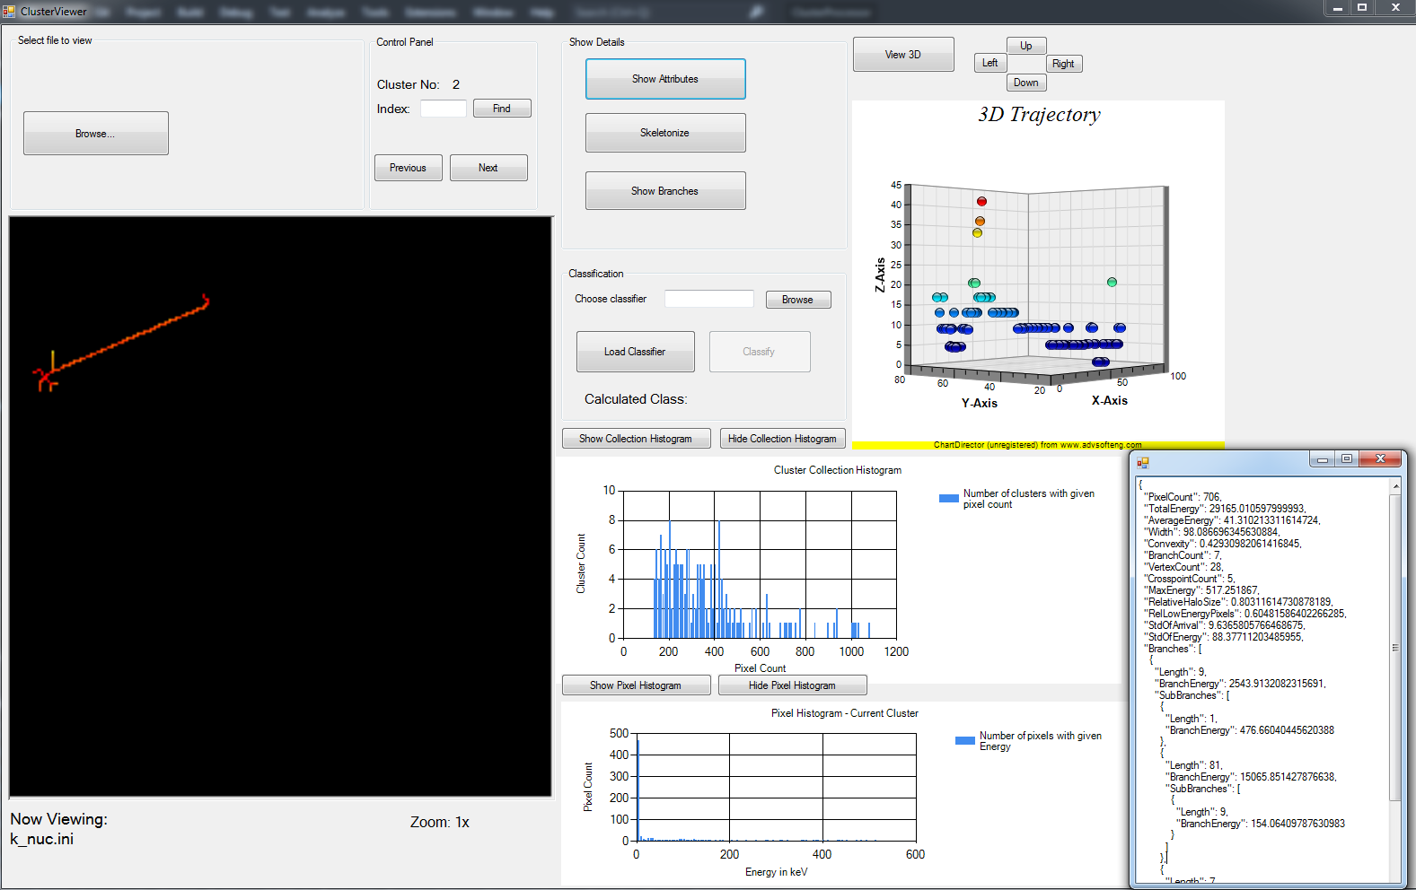

Figure 3.1 User interface of the ClusterViewer application

Figure 3.2 Cluster viewer user interface

## Loading a cluster file

To view clusters, we run the viewer and either enter the path to our .ini or .json

file or click the Browse button, and select the cluster file.

If the message "File was loaded successfully"appears, it means that our collection of clusters is now ready for viewing. Otherwise, a problem occurred during the loading of the file. The error is further specified in a message box. Some of the common causes are:

* .ini file does not exist or is inaccessible,
* .cl and .px files referenced by the .ini file do not exist or are inaccessible,
* .cl, .px or .ini file is not in the correct format.

## Browsing clusters

To view a particular cluster, the user can use the ClusterViewer application, which is capable of displaying the 2D representation of the cluster. The image of the specified cluster displays the energy of each pixel logarithmically mapped to the color spectrum starting from white (for pixels with energy below 2eV) through yellow (for pixels with energy greater than 2eV and less than 15eV) to orange and red (pixels with energy up to 500eV), see Figure 3.2. If the same pixel is hit twice in the cluster, the pixel is displayed with the higher energy.



Pixel Energy around 5keV

Pixel Energy around 20keV

Energy more than 200keV

Figure 3.3 Displayed cluster color mapping

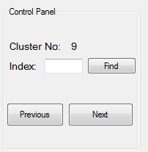After the cluster collection is loaded, we can navigate through the collection using the Previousand Nextbuttons. To find the -th cluster (clusters are numbered from 1) in the collection, we can select the index of the cluster in the Control Panel box and click the Findbutton.

Figure 3.4 Panel for navigating through the collection of clusters

## Histograms

Apart from collection browsing, users can also view histograms. There are two histograms available in the viewer:

* 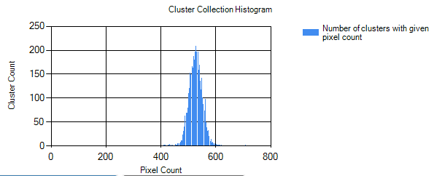Collection Histogram displays the histogram of the whole collection for the pixel count attribute.

Figure 3.5 Example of a cluster collection histogram

* Pixel Histogram represents the histogram of the pixels of the currently viewed cluster for the energy.

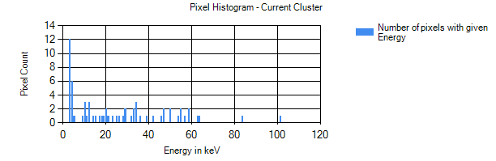

Figure 3.6 Example of a pixel histogram

Both histograms are calculated and displayed after clicking Show Collection Histogram (or Show Pixel Histogram) button.

## 3D visualization

Figure 3.7 Cluster trajectory visualization

Based on the time of arrival and calibration data, it is possible to reconstruct the trajectory of particles in the cluster. To get a better idea of how the trajectory of the cluster looked like, we can visualize the cluster in 3D. The visualization is based on the ToA (time of arrival) of each pixel.

* **Viewing:** To view the three-dimensional image of the cluster, the user can click the View 3D button.
* **Rotation**: After the image is displayed, the user can rotate the image around the -axis and -axis by clicking the Up, Down, Left, and Right buttons.

## Cluster Attributes

By clicking the button Show Attributes located in the Cluster Details section, various cluster properties are displayed. All these properties must be calculated in advance and stored in the cluster file (extension .cl). These attributes range from straightforward like Total Energy and Maximum Energy to the more sophisticated ones like Branch Count and Relative Halo Size.

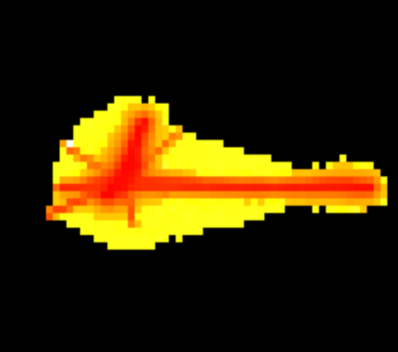

Figure 3.8 Example of a cluster with high energy (red), non-trivial halo (yellow) and branch count

Figure 3.9 Example of a simple cluster with lower total energy. It contains only a single branch without a significant halo effect.

## Skeletonization

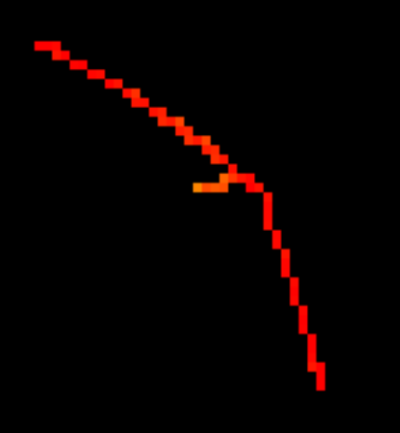 Skeletonization is a process of transforming an image into a skeleton by reducing the original image that contains different thicknesses into a set of curves and lines. Skeletonization can be used to remove the halo effect of the clusters while preserving the shape of the original cluster. During the skeletonization process, as the image is thinning, pixel energy is split among its neighbors. This means the total energy of the cluster and its skeletonized version is the same. To view the skeleton of the original cluster, we click Skeletonize.

Skeletonization

Figure 3.10 Cluster after skeletonization

Figure 3.11 Cluster before skeletonization

## Branch analysis

After finding the skeleton of the cluster, we can try to detect particle trajectories in the cluster. To do so, we can click the Show Branches button. The center point of the cluster is represented by the white dot, while the separate branches are denoted by distinct colors – blue, red, and green. Each branch can have its sub-branches – the starting point of the sub-branch is contained in its parent branch. The sub-branches are highlighted by a lighter shade of their parent branch color.

Branch 1

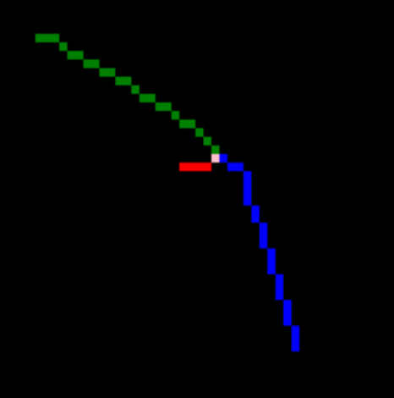

Branch 2

Branch 3

Center (crosspoint)

Figure 3.12 Branches of a cluster

## Classification

Using all the features we are able to calculate for the cluster, we can classify the cluster into various categories. This classification is done via machine learning using neural networks. The default classes of particles that are implemented in the default bestClassifier.csf classifier are:

* lead,
* iron,
* helium,
* muon,
* electron,
* pion,
* low energy electron,
* and proton.

In the viewer application, a user can load a classifier by clicking Load Classifier and choosing the right trained classifier in .csf file. When the classifier is successfully loaded, it can be used to classify the currently viewed cluster.

# Filter

The ClusterFilter application serves as a tool for picking the clusters that fit the given criteria. The user interface of the Cluster Filter application is very similar to the Cluster Viewer.

1. As the first step, we select the input .ini file. This can be done either by typing in the path to the file or clicking the Browse button.
2. Then, we choose the name for the output .ini file.
3. After that, we can select the properties to filter by and set the lower and upper bounds for the property. If no bound (upper or lower) is specified, the filter automatically sets the bound to the maximum (or minimum) possible value.
4. To start the processing, we click the Process button. During the filtering process, a new .cl file is created. The newly created file contains only those clusters, which fit the filtering criteria. However, no .px file is created because the output reuses the original pixel file to speed up the calculation and prevent unnecessary copying.
5. After the filtering is done, the filter displays the message "Filtering completed successfully." If any other message is shown, it means there was an error. The message should provide more information about the problem. In most cases, it is either an incorrect data format or file inaccessibility.

# DescriptionGenerator

The Cluster Description Generator is a tool for calculating attributes for the whole collection of clusters at once. This can be useful, e.g., when creating training data for the machine learning algorithms. The collection of clusters can be composed of clusters from several source files. The application combines clusters from several sources and produces a new collection of clusters (.ini, .cl, and .px file) containing the selected clusters together with computed attributes. The detailed instructions on how to use the tool follow:

1. We start by clicking the Browse and Add… button, where we select one or more .ini files and add them to the Selected Input collection.
2. To add more input files, we can repeat the process until all desired files are shown in the Selected Input box, as shown in Figure 5.1.
3. To remove elements in the collection, we click the Remove Selected button.
4. For every single file we select, we can edit its Class Name column by triple-clicking – there can be multiple files containing the same class. This way, we set the name of the particle present in the input file, which can then be used for the supervised machine learning algorithms.

“Proton“ class partitions

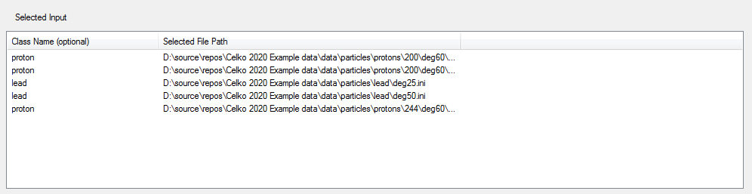

“Lead“ class partitions

Figure 5.1 Selected partitions in Description Generator

1. Then, we can choose the output file name in the Select output text field and also tick the attributes that will be calculated. To include the cluster class name as an attribute, remember to tick the Class attribute (which will not be actually calculated, it will just be copied from the provided class name).
2. After that, we can choose either the **even** distribution of each class in the output or the distribution **proportional** to the particular class size. Even distribution of the class means that each class has the same chance to be processed as the next cluster. In contrast, proportional distribution means the chance of picking clusters from a class with smaller datasets is smaller, while classes with bigger datasets are more likely to be picked.
3. For each file with a given class (further referenced as a class partition), we can choose whether we want to process those in a serial order (provided by the order on input – the next partition is processed after the previous was already fully processed). Another option is the **parallel order** (after a single cluster from the current partition is processed, a cluster from the next partition is set to be processed next).
4. The user can also select the **ending condition** of the process. When this condition is satisfied, the program finishes the calculation – for a large number of clusters, the process may take several minutes to complete. There are three types of ending conditions:
   1. Any partition is fully processed (**First partition**)
   2. Some class is fully processed (**First class**)
   3. All classes are fully processed (**Last class**)

By default, no cluster on the input will appear in the output more than once. When generating the data for imbalanced classes (in the real-world data, there are huge differences in class sizes), this could lead to problems with the machine learning classification of the less frequent classes. To compensate for that, we can choose the Align class option. By selecting the align class, any other class partition that is processed will not be discarded but will be processed repeatedly until the specified Align class is fully processed.

# Classifier

The ClassifierForClusters is a console application that provides an interface for the classification process of the selected clusters. The prerequisite for the classifier is to have Accord.net NuGet packages installed.

Syntax:

**ClassifierForClusters.exe [trained_classifier.csf] [file_to_classify.json] [options]**

|  |  |
| --- | --- |
| Command-line options | |
| --simple or --multi | Specification of the classifier type (single-level or multi-level), default is single. |
| --distr | Print only key-value pairs of the class name and its frequency. |
| --default | Label each cluster with a class and print the frequencies of the classes to the console. |
| --specials | Label each cluster with a class (same as --default), print frequencies while also create a file for non-trivial unclassified clusters. |
| --multiFile | The clusters are split into separate JSON files according to the predicted class and print key-value pairs of the frequencies to the console. In order to be able to view the results in the ClusterViewer, the cluster must contain attributes ClFile, PxFile, and ClIndex. |
| --singleFile | Print all labeled clusters to a single JSON file. |

Table 6.1 Options of ClassifierForClusters application

# ClassifierUI

Classifier UI is a tool that enables training classifier models based on the input parameters. User needs to set:

* **Training Json file** = training data in JSON format,
* **Classifier config file** = parameters of the classifier in JSON format,
* **Trained model** = If we want to re-traini an existing model of single-level classifier, we fill this field with its configuration .csf file.
* **Minimal accuracy** = When this level of accuracy (or better) is reached on the validation set (the data which the classifier did not see during training), the training stops, and the classifier is stored into a file. It is a value between 0 and 1.
* **Maximal repetition count** = The maximal number of times we will try to train our classifier to reach the target accuracy.
* **Seed** = Integer value, based on the value of the seed, data is split randomly into training and validation sets (where 90% of the data is used for training and the remaining 10% for validation).

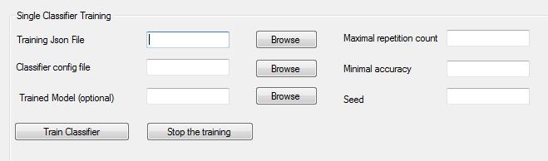

Figure 7.1 Classifier training dialog

The UI also provides an option to combine up to 4 simple trained classifiers into a multi-level classifier. Users can choose the root classifier that will be applied first. The first classifier classifies the input clusters into several classes. One of these classes can be selected as a "Split Class." All clusters classified into the split class by the first classifier are fed into the classifier Trained Model Lv1 for further classification. Among the output classes of the Trained Model Lv1 classifier, another split class can be selected, and so on. That means, for combining classifiers, we need to fill in split classes because the bottom level classifier cannot have a split class. If you use only two classifiers (root and Lvl 1), make sure all the other fields for classifiers are empty.

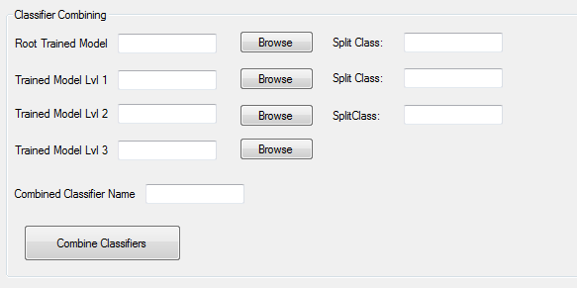

Figure 7.2 Classifier combining dialog

The example below shows a multi-level classifier that uses three simple classifiers and two split classes.

Figure 7.3 Example of a multi-level classifier

# ClassifierTrainer

ClassifierTrainer is a console application that can train a classifier. This application can be used instead of ClassifierUI. Both tools can train the same classifier and differ only in their interfaces.

Syntax:

**ClassifierTrainer.exe [training_data.json] [network_parameters_config.json] [options followed by their value (space separated)]**

Example

ClassifierTrainer.exe lead_training data.json lead_network_config_parameters.json --acc 0.8 --seed 42 --maxrep 5

|  |  |
| --- | --- |
| Command-line options | |
| **--trained** | (Optional) Indicates existing .csf file should be trained again instead of creating a new classifier. A path to the trained model should follow this option. |
| **--acc** | Sets the target accuracy of the classifier on the validation set to save the result. Must be followed by the accuracy value between 0 and 1. |
| **--seed** | Sets the seed. According to this seed, the data is split into the training and validation sets. It is followed by an integer value. |
| **--maxrep** | Sets the maximal number of passes through the dataset. The training ends when either minimal accuracy on the validation set is achieved or the number of passes through training set reached maxrep. |

Table 8.1 Command line parameters of the ClusterTrainer

# ClassifierExperiment

The ClassifierExperiment is a console application for performing experiments with the classifiers. It accepts only a single parameter – a path to the directory where the training and testing data, together with trained model directories, are located. The folder with the data for the experimets is accessible at <https://drive.google.com/file/d/1f_t0RE7KiqO69yrzWAbU8LSX8r3l4m_J/view?usp=sharing>. (Note: The data and models must not be in the same folder, their parent directories must be in the specified folder).

Syntax:

**ClassifierExperiment.exe [path to the directory that contains the train_data, test_data, and trained_models directories]**

To verify that the classifier bestClassifier.csf was successfully loaded, it is tested on the test dataset, and the result is displayed in the console. To check the performance of each single-level classifier, we trained the following types of classifiers:

1. – classifies the particles into lead particles and the rest. This classifier was trained on roughly 80000 clusters.
2. – separates fragments, helium, and iron from each other and the rest. The training dataset for this classifier consists of 450000 clusters.
3. – separates low-energy electrons from protons and from the rest. The total number of clusters we used during the training is more than one million.
4. – splits clusters into four classes – electrons, muons, pions, and the artificial class elPi0. The artificial class elPi0 contains … It is trained on the dataset of approximately 500000 clusters.
5. – splits clusters into all categories directly (including the artificial category elPi0) and is trained on roughly 100000 clusters.

During the training process, the user can see the training (mean squared) error after the given number of iterations. The experiments executed are the following:

1. **Evaluation of the best-trained model on the test dataset** is displayed in the form of a confusion matrix of classified particles. We decided to use this as a "sanity check" to quickly determine whether the correct data directory was downloaded andwhether it has the expected structure (it is more of a quick check rather than a rigorous check of the whole dataset).
2. **Comparison of the accuracies of the classifier models with different learning parameters by altering their default values displayed in** Table 9.1**:**

|  |  |
| --- | --- |
| **validAttributes** | TotalEnergy, AverageEnergy, MaxEnergy, PixelCount, Convexity, Width, CrosspointCount, VertexCount, RelativeHaloSize, BranchCount, StdOfEnergy, StdOfArrival and RelLowEnergyPixels |
| **layerSizes** | [13, 13] |
| **learningAlgorithm** | backProp |
| **epochSize** | 8 |
| **learningRate** | 0.6 |
| **momentum** | 0.5 |
| **activationFunction** | sigmoid |

Table 9.1 Default model parameters

1. ***Lower learning rate and momentum*** 
   * learning rate: 0.1, and
   * momentum: 0.1.
2. ***Medium learning rate and momentum***
   * + learning rate: 0.5, and
     + momentum: 0.5.
3. ***Higher learning rate and momentum***
   * learning rate: 1, and
   * momentum: 1.
4. ***Small number of hidden layers***
   * A single hidden layer with one neuron.
5. ***Medium number of hidden layers***
   * Two hidden layers with 13 neurons each.
6. ***Higher number of hidden layers***
   * Three hidden layers with 13 neurons each.
7. **Comparison of the single-level classifier accuracy with the multi-level classifier.** We trained 10 multi-level and 10 single-level classifiers (we verified the models were properly trained by observing the training error that was not decreasing) and compared their accuracy.
8. **Calculation of the k-fold cross-validation for each type of the single-level classifiers used in the bestClassifier.csf.** To check the performance of each single-level classifier, we trained the following types of classifiers:

Then, we calculated their accuracy on a test fold (we performed a 6-fold validation)

Note: the execution of the tests could take a significant amount of time (around an hour for the first two tests each, the last test took less than 10 minutes) because of the large training datasets. The experiments were run on the desktop with the following parameters:

CPU: Intel i5-66000K, 3.5GHz,

GPU: NVIDIA GeForce GTX 1060

RAM: 8GB,

SSD: 256GB,

Address space: 64-bit,

OS: Windows 7.

# Demonstration

In order to guide the user through the whole ClusterProcessor solution, we decided to create a brief demonstration. Users can go step-by-step and gain intuition on how to use the applications.

## Preparing the data

* + Download the binary files or clone the repository at <https://github.com/TomSpeedy/ClusterProcessor>. For further information, see Chapter 2.
  + Download the sample dataset from <https://drive.google.com/file/d/1f_t0RE7KiqO69yrzWAbU8LSX8r3l4m_J/view?usp=sharing>
  + Inspect the downloaded data file – it consists of 4 folders:
    1. **train_data** are used for training the neural network classifiers in JSON file format. These contain both the examples of clusters used for training as well as training parameters of the networks.
    2. **test_data** are data in JSON file format used for testing of the classifiers trained on a different dataset (train_data).
    3. **demo_data_MM** represents the clusters in MM format, which are split into multiple directories based on their class (e.g., proton, electron).
    4. **trained_models** contain the classifier models which were already trained and can be used for classification or (in the case of single-level classifiers) for further training.

## Filtering

When we have the data and applications prepared, we can navigate the ClusterFilter binary folder (/bin/Release). Its structure should match the one displayed in Figure 10.1.

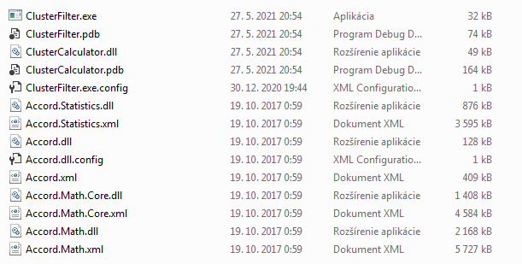

Figure 10.1 Filterer application folder with executable binary

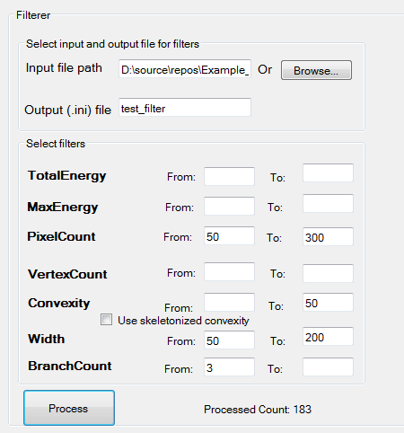

* By double-clicking **ClusterFilter.exe,** the application is run, and the form is opened.
* Then, we click Browse, and in the dialog, we select the file **demo_data_MM/frag/k_nuc.ini**
* We also choose the name for our output file as **test_filter.**
* Now, we choose the filtering parameters as displayed in Figure 10.2.

Figure 10.2 Filled filterer form

* We click the Process button, and we are immediately informed that the filtering is done.
* 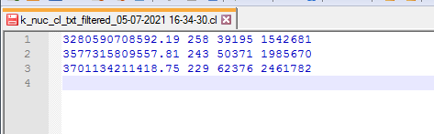The output file is in the same directory as the input file and contains three clusters, as displayed in Figure 10.3.

Figure 10.3 Output file from filterer containing only 3 clusters

## DescriptionGenerator

* We navigate to the folder with description generator executable binary (**/bin/Release**).
* By double-clicking on **DescriptionGenerator.exe** we open the form.
* We click Browse and add button and select **demo_data/electron/deg0.ini**
* We click Browse and add button and choose **demo_data/fe/3_0.ini**
* We click Browse and add button and choose **demo_data/pion/f3_0.ini**
* The selected partitions are displayed in the form as shown in Figure 10.4.

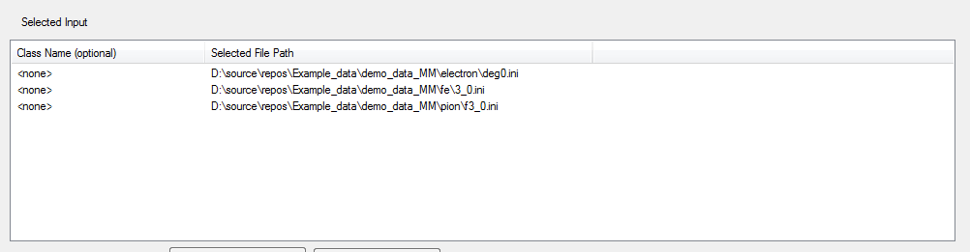

Figure 10.4 Selected inputs (partitions) for description generation

* We can now choose a class name for each of the three partitions – electron and pion are leptons while the iron is an atom, so we can edit the class name based on that by triple-clicking on the class name (which has value <none> by default).
* After editing the partitions, we select the name for the input as **test_description**
* Then, we can decide to calculate all possible attributes by clicking Check All Attributes. The form should look similar to the one displayed in Figure 10.5.
* After clicking Process, the program starts processing the input files and creates the output file. It should only take a couple of seconds until we are shown the message box informing us that the processing is over.

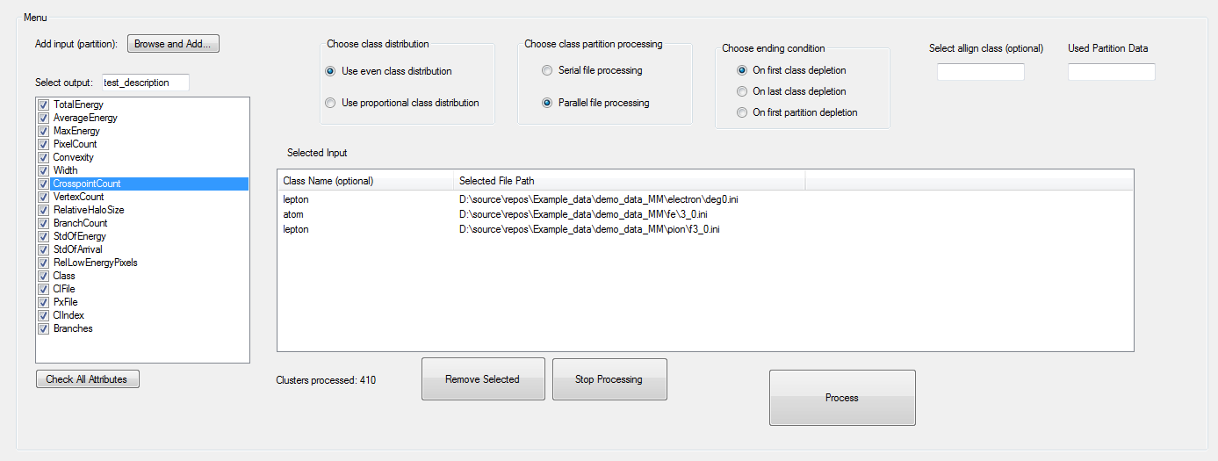

Figure 10.5 Description generator form before processing

* The output file contains the descriptions starting with a cluster, as shown in Figure 10.6.

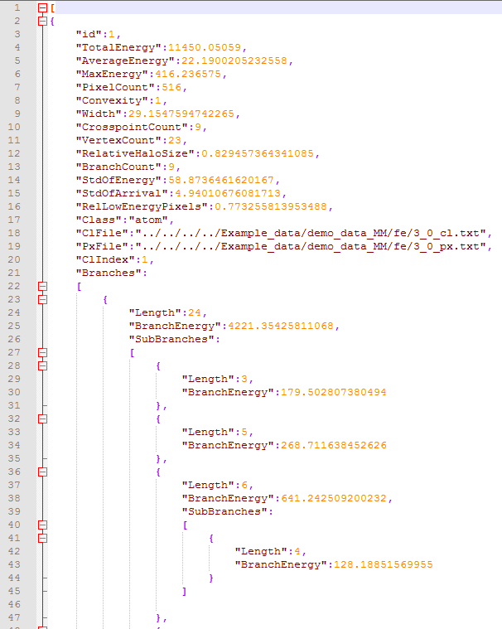(Note: the ClFile and PxFile values may be different based on the relative path of the output file to the original files in MM format)

Figure 10.6 Beginning of the output of the description generator

## Classifier

* We navigate to the folder with ClassifierForClusters executable binary (**/bin/Release**).
* We run the executable file **ClassifierForClusters.exe** with the following arguments:
  + [relative or full path to **trained_models/bestClassifier.csf**] (in our case "D:/source/repos/Example_data/trained_models/bestClassifier.csf")
  + [relative or full path to **test_data/testCollection.json**] (in our case, "D:/source/repos/Example_data/test_data/testCollection.json")
  + **--default --singleFile --multi**
* 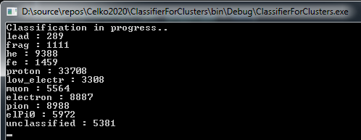"Classification in progress.."appears, and after a couple of seconds, the particle frequencies are print to the console, see Figure 10.7.

Figure 10.7 Console output of the classifier

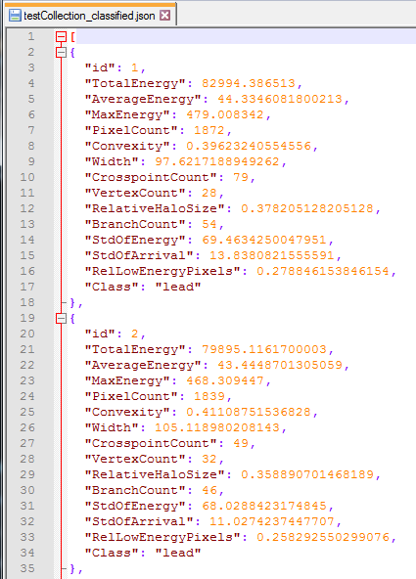

Figure 10.8 Beginning of the labeled clusters file (output of the classifier)

* When we navigate to the folder test_data, we can see the former collection of clusters (testCollection.json) and the created classified collection file **testCollection_classified.json,** which starts with the clusters displayed in Figure 10.8.

## ClassifierUI

*Classifier Training*

* We navigate to the folder with ClassifierUI executable binary (**/bin/Release**) and run the application **ClassifierUI.exe**.
* When the form (and a console window) is opened, we select the training file by clicking Browse and choosing **train_data/trainPrLe_ElMuPi.json.**
* Then, we select the classifier config file by clicking Browse and choosing **train_data/PrLeNetworkConfig.json.**
* 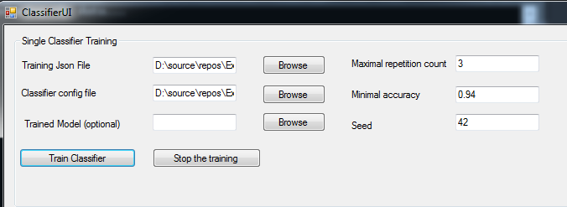We will leave the trained model field empty because we want to train a new model. We set the Maximal repetition count to 3, minimal accuracy to 0.94, and seed to 42, as displayed in Figure 10.9.

Figure 10.9 Filled classifier form before training process

* We click Train Classifier button. In the console, "Analyzing the data.. " is displayed, followed by the error rates of the classifier after each iteration, as shown in Figure 10.10.
* The trained classifier can be found in the same directory as the training dataset under the names **trainPrLe_ElMuPi.json_trained_0.95_[date].csf** and **trainPrLe_ElMuPi.json_trained_0.95_[date].csf_support** (so it consists of the training dataset name,the accuracy of the classifier, and the current date)
* 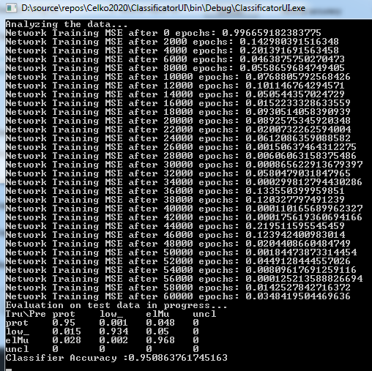Important note: Used implementation (Accord.Net) does not allow network weight initialization based on a seed. The seed is only used for splitting the dataset into training and testing data. This means that user's results might vary slightly when running the program.

Figure 10.10 Console output during the training process

*Classifier Cascading*

* To combine a couple of trained classifiers into a multi-level classifier, we can use the bottom part of the UI.
* Click Browse button next to the Root Trained Model label and select **trained_models/trainFragHeFeNew.json_trained_0.961.csf** and type **other** into its Split Class field. This classifier splits the data into the following classes:
  + frag,
  + he,
  + fe,
  + and other (electrons, proton, pions, and muons combined).
* Click Browse button next to the Trained Model Lvl 1 label and select **trained_models/trainPrLe_ElMuPi.json_trained_0.966.csf** and type **elMuPi** into its Split Class field. This classifier splits the data into the following classes:
  + low energy electron,
  + proton,
  + and other.
* Click Browse button next to the Trained Model Lvl 2 label and select **trained_models/trainElMuPi.json_trained_0.801.csf,** and leave its Split Class field blank as shown in Figure 10.11. This classifier splits the data into the following classes:
  + electron,
  + muon,
  + pion,
  + and elPi0 (electron or pion with an angle of zero degrees).
* We choose the classifier name **combined_test** (or you can type in a path with a name to create the output file in a different directory) and click the Combine Classifiers button.

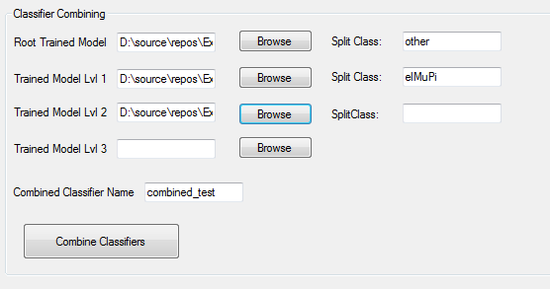

Figure 10.11 Classifier combining form before the start of combining process

* 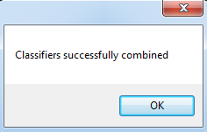After that, a user is informed that the combining was successfuly completed, as displayed in Figure 10.12. Then, the combined classifier (in our case) is stored in the working directory as **combined_test.csf** and **combined_test.csf_support.**

Figure 10.12 Message box indicating success of the combining process

## ClassifierTrainer

* We navigate to the folder with ClassifierUI executable binary (**/bin/Release**).
* Then, we run the executable file **ClassifierTrainer.exe** with the following parameters:
  + [full or relative path to **train_data/trainPrLe_ElMuPi.json**]
  + [full or relative path to **train_data/PrLeNetworkConfig.json**]
  + **--acc 0.94**
  + **--maxrep 3**
  + **--seed 42**
* In the console, "Analyzing the data.. " is displayed, followed by the error rates of the classifier after each iteration and evaluation in the form of a normalized confusion matrix.
* The trained classifier can be found in the same directory as the training dataset under the names **trainPrLe_ElMuPi.json_trained0.95.csf** and **trainPrLe_ElMuPi.json_trained0.95.csf_support** (the name contains the accuracy of the classifier, which means the actual filename may contain a different number than 0.95)

## ClusterViewer

* We navigate to the folder with ClassifierUI executable binary (**/bin/Release**) and run the application **ClusterUI.exe**.
* Click on the Browse button and select **demo_dataMM/lead/deg0.ini.** The collection is loaded, and the following are displayed – information about the current zoom and the name of the viewed .ini file, see Figure 10.14.
* Then we fill in the index of a searched cluster **23** and click the Find button. A new cluster is loaded with a given index in the collection, as displayed in Figure 10.13.

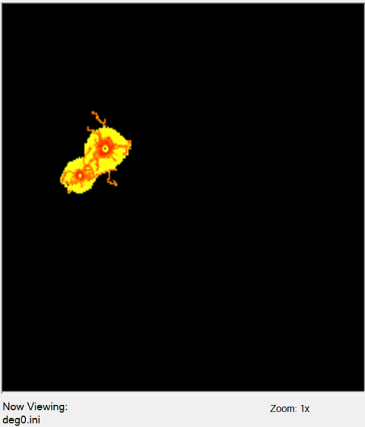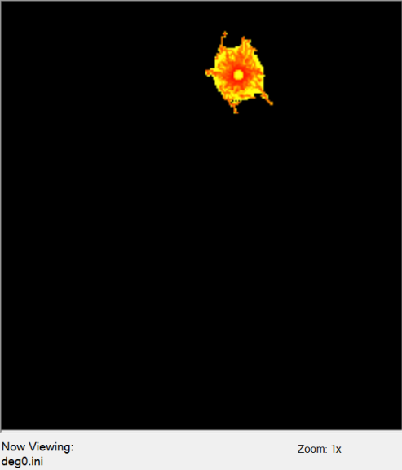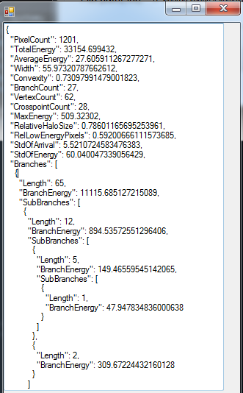

Figure 10.13 Image of the 23rd cluster in the collection

Figure 10.14 Image of the first cluster in the collection

* After clicking Show Attributes, the list of attributes of a cluster is displayed, see Figure 10.15.
* When we click Skeletonize button, the skeleton of a cluster is shown, as displayed in Figure 10.16.

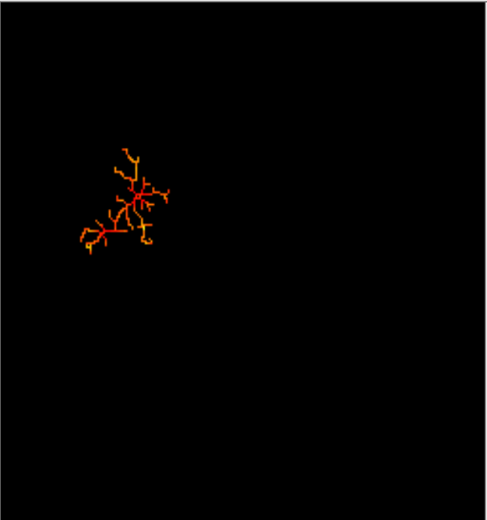

Figure 10.15 Attributes of a cluster in JSON data format

Figure 10.16 Skeletonized cluster

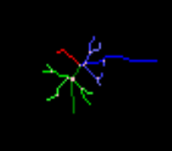

* Then, we go to the cluster with index **35** and click the Show Branches button. This displays branches detected in the cluster, as shown in Figure 10.17.
* We click Browse again to load the file **demo_data_MM/frag/k_nuc.ini,** search for the 7th cluster and click Skeletonize button.

Figure 10.17 Branches found in the cluster

* 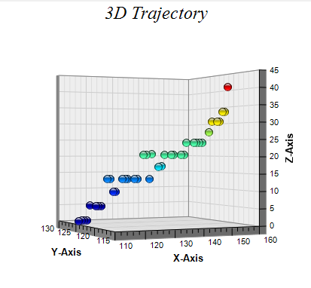After that, we click the View 3D button and use the rotation buttons to view the trajectory from different angles (see Figure 10.18).
* By clicking Show Collection Histogram and Show Pixel Histogram buttons, we are displayed the histograms for the whole collection and for the currently viewed cluster, respectively.
* 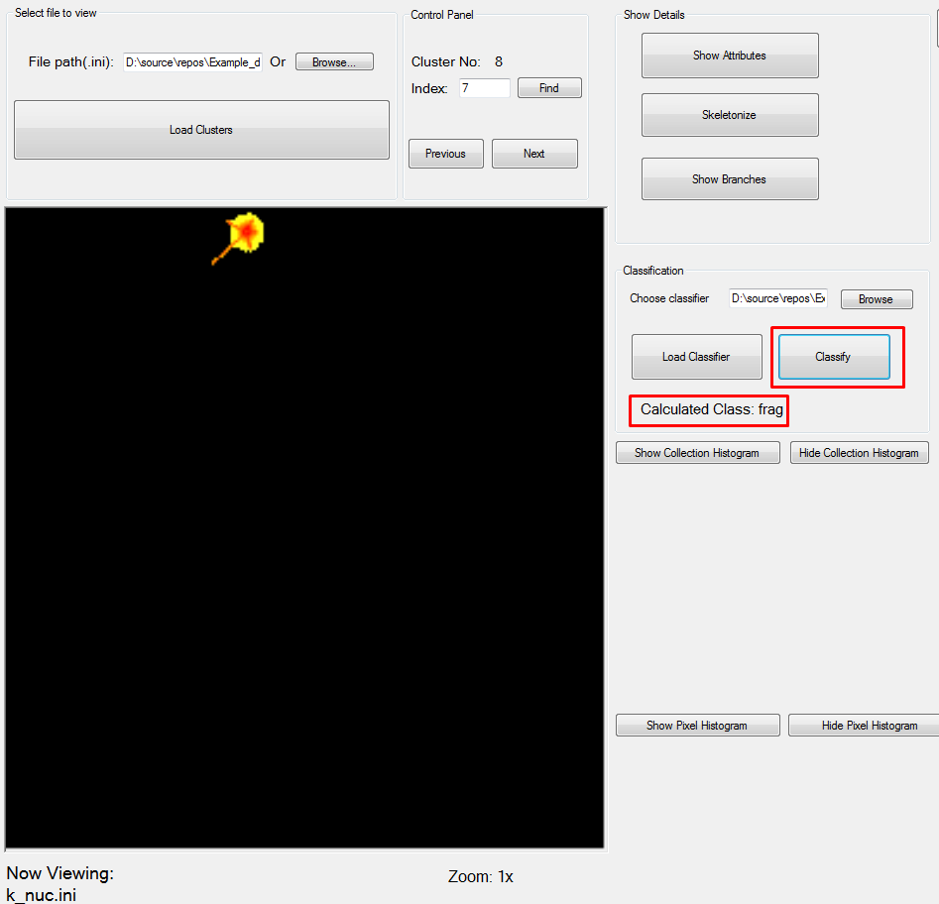We now click on the Next button to move to the next cluster. Then, we click the Browse button in the Classification section and choose **trained_models/bestClassifier.csf,** which loads the given classifier into the viewer. Then, we can click on classify for each of the currently viewed clusters, which displays the label with the predicted class (see Figure 10.19.

Figure 10.18 3D trajectory of the particle

Figure 10.19 Classification of the current cluster in the cluster viewer

# Further troubleshooting

In case you have any problems that were not addressed by this manual, or should you have any questions regarding the ClusterProcessor, feel free to contact us at <mailto:celko.tom@gmail.com>. We appreciate feedback of any kind, and we hope that the application is helpful in anything you would like to use it for.